**SCREEN DESIGN**

**AUTHORS**

**JAKOB | BRAYDEN | ALEX**

**Login Screen**

Functionality: The functionality for this page is to link and tie all pages together. The welcome page is used to enter an email and password which has already been given to you inside the database. The welcome screen displays four buttons

* Sign in: Used to log the user in from the database
* Sign up: Used to put a user in to the database.
* Reset: Used to reset the text inputted
* Exit: Used to exit the application.

Design: The colours and design of the page have been made to allow for simple and easy use of the application. This has been accomplished with clean and simple to use buttons to guide the user to their desired location and colours which pair up nicely with each other.

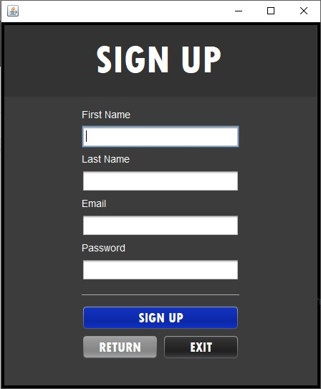

**Sign Up Screen**

Functionality: The functionality for the signup page is to allow a user to input their first name, last name, email and password and for it to be registered inside the database to be later used to login with. The Signup screen displays three buttons

* Sign up: Logs the information given in to the database
* Return: Takes the user back to the Login screen
* Exit: Used to exit the application

Design: The colours and design have been kept the same from the Login screen to keep consistency.

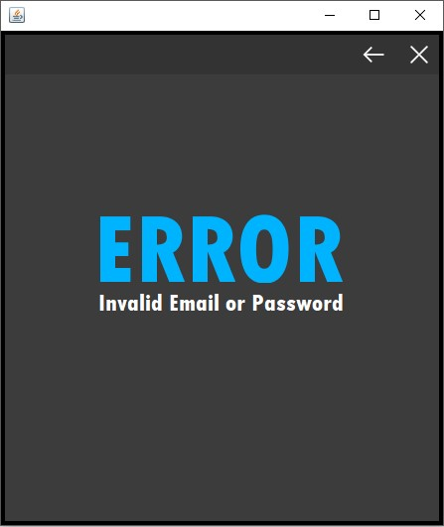**Error Invalid Email or Password**

Functionality: This page is used to alert the user that their email or password which they entered in to the login page is incorrect or invalid. The error page displays two buttons

* Return: Takes the user back to the Login screen
* Exit: Used to exit the application

Design: The design has been kept the same with a simple GUI and colours which have remained the same throughout the pages.

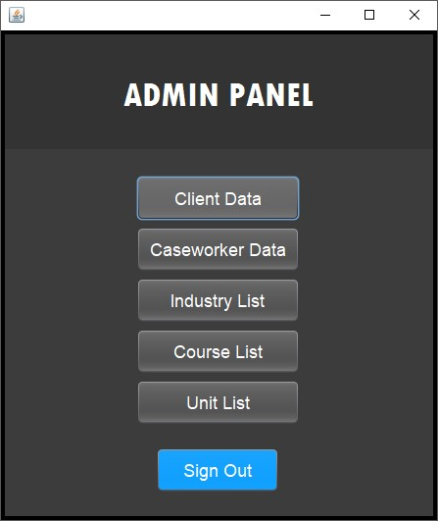**Admin Main page**

Functionality: This page is the main panel display for admins after they login. They can see all panels and controls they have access to and can also sign out. There is 6 buttons on this page.

* Client Data, Caseworker Data, Industry List, Course List, Unit List take you to their respective pages for the admin to edit and view the information.
* Sign out: Signs out the admin and takes you back to the login page

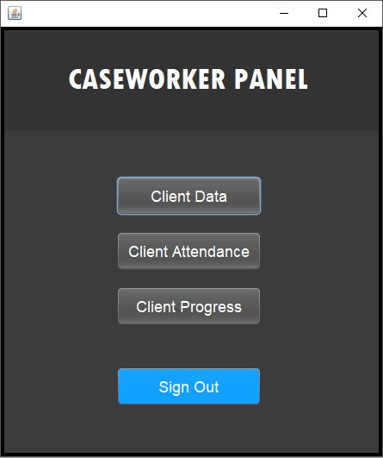

**Caseworker Main page**

Functionality: This page is the main panel display for caseworkers after they have successfully logged in. They can all the panels and controls they have access to and can also sign out. Unlike admins caseworkers cannot edit, insert, or update data but only view it. There is 4 buttons on this page.

* Client Data, Client Attendance, Industry List, Course List, Unit List take you to their respective pages for the admin to edit and view the information.
* Sign out: Signs out the admin and takes you back to the login page

**Client Data Admin page**

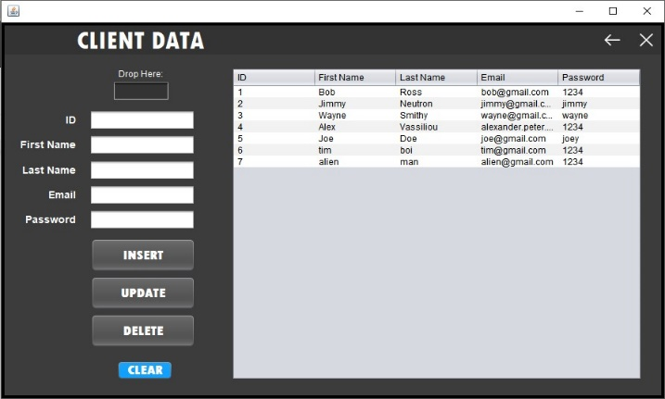Functionality: This page allows an admin to view, insert, update or delete client data inside the database. The Client data admin page displays 6 buttons and a drop here box.

* Drop here: Drag and drop information from the table in to the drop here box to display the information in the boxes underneath
* Clear: Clears information inside the text boxes
* Insert: Inputs text inside the text boxes in to the database
* Update: Updates the existing information with modified text inside the text boxes.
* Delete: Deletes the selected client data from the database
* Back: Takes you back to the admin main GUI
* Exit: Closes the application

Design: The design has been made wider to hold the table and extra text boxes and buttons but still keeping the same colours and feel.

**Client Data Caseworker Page**

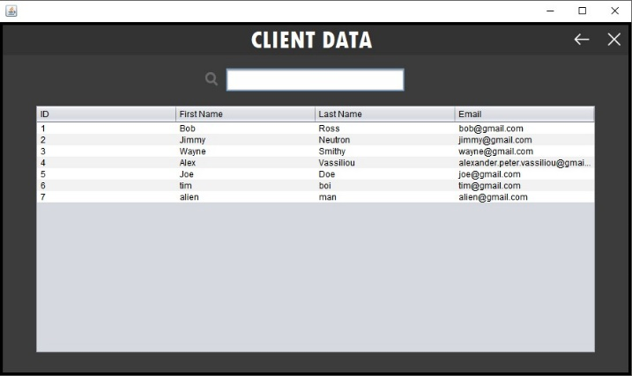Functionality: This page allows a caseworker to only view and search the client data but does not allow them to insert, update or delete any information. The client data caseworker page displays 2 buttons and a search box

* Back: Takes you back to the caseworker main GUI
* Exit: Closes the application
* Search: allows you to type in a client’s name and it automatically appears at the top.

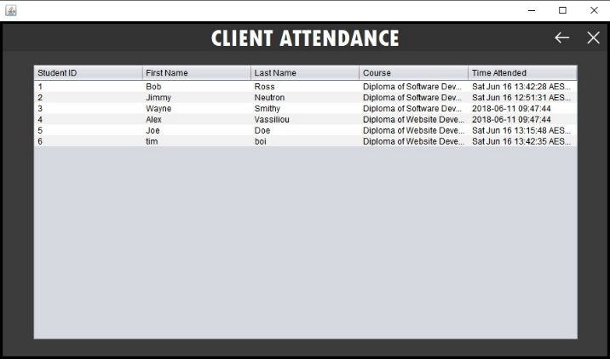

**Client Attendance Page**

Functionality: This page allows a caseworker to view and search individual client attendance throughout the application and see when clients login. This page has 2 buttons

* Back: Takes you back to caseworker main GUI
* Exit: Closes the application

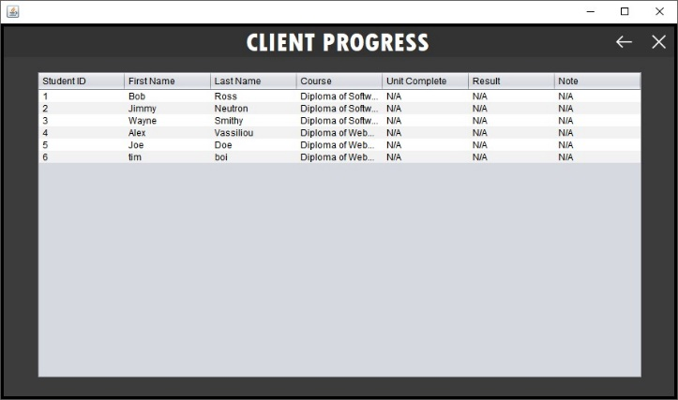

**Client Progress Page**Functionality: This page allows a caseworker to view and search individual client progress, enrolments and results. This page displays 2 buttons

* Back: Takes you back to caseworker main GUI
* Exit: Closes the application

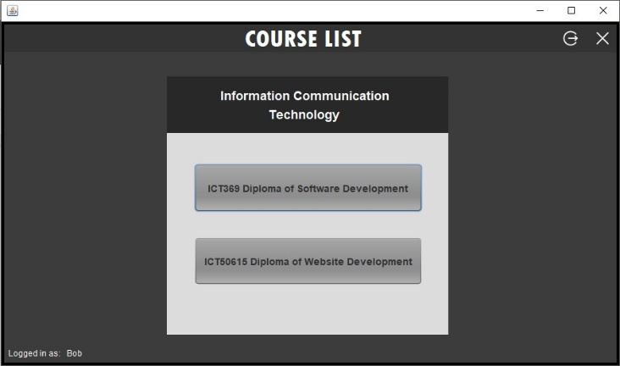

**Client Course List Page**

Functionality: This page is the main page after the login screen clients will see when signing in. A client is displayed two courses to choose from. This page displays 4 buttons

* Sign Out: Takes you back to login page
* Exit: Closes the application
* First and second course: Takes you to the first and second course to choose what you want to enrol in.

**Client Unit List Page**

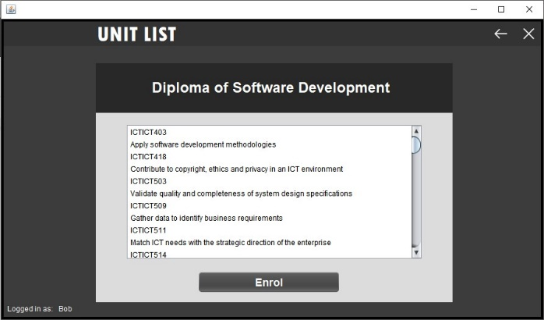Functionality: This page is the unit list page which displays all the units within the selected course. From here the client can decide to enrol in the course and it will be updated in the database.

There is 3 buttons

* Back: Takes you back to client course list page
* Exit: Closes the application
* Enrol: Enrols the logged in user in the certain course they picked.

**Client Unit List Admin Page**

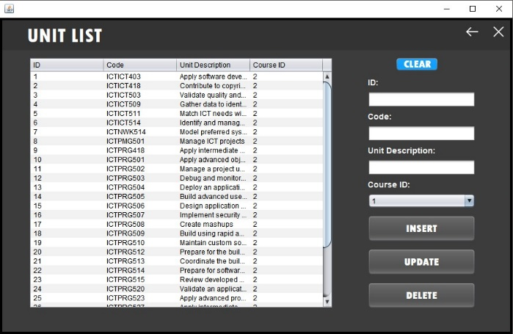  
Functionality: This page is the unit list admin page and displays all the units for each course for the admin to insert, update, and delete original or new units. There are 6 buttons on this page

* Back: Takes you back to client course list page
* Exit: Closes the application
* Clear: Clears information inside the text boxes
* Insert: Inputs text inside the text boxes in to the database
* Update: Updates the existing information with modified text inside the text boxes.
* Delete: Deletes the selected unit data from the database

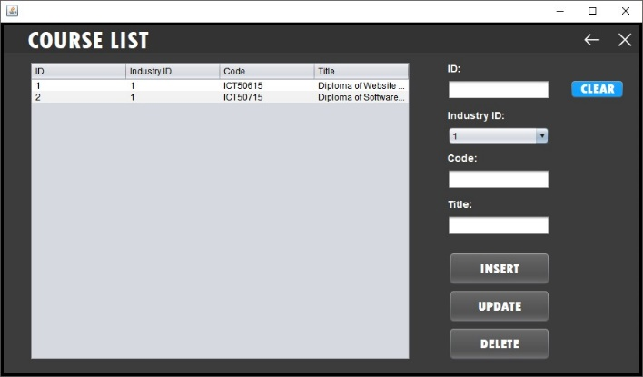**Client Course List Admin Page**

Functionality: This page is the course list admin page and displays all the courses for each industry for the admin to insert, update, and delete original or new courses. There are 6 buttons

* Back: Takes you back to client course list page
* Exit: Closes the application
* Clear: Clears information inside the text boxes
* Insert: Inputs text inside the text boxes in to the database
* Update: Updates the existing information with modified text inside the text boxes.
* Delete: Deletes the selected course data from the database